SQL Query to create table eventplanline :

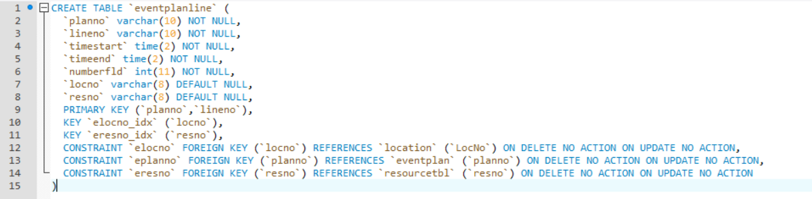

Eventplanline tale :

